1.Question 1

what is the order of the following Polynomial

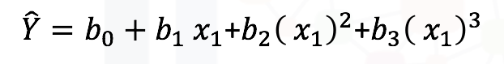



2



1



3

1 point